1. The mov works really fast, to do so it needs to be very efficient. mov works extraordinarily fast by sending all the information as 32 bits. That’s why mov only accepts some number (those with at least 24 bits set to 0).

2. use of ORR command to convert the value into executable number can work.

3. 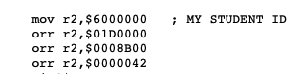

**OK2**

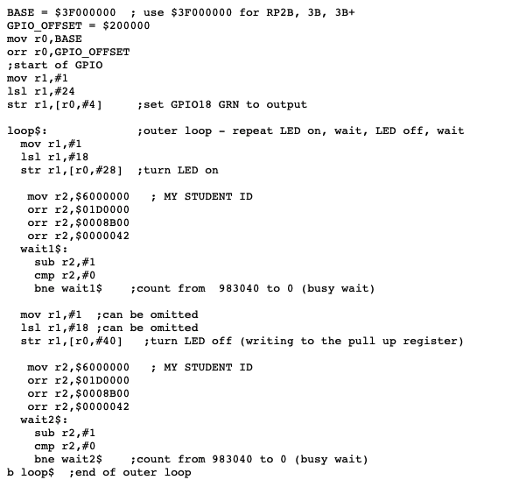

**OK4**

